Aron Ryan

arondanteryan.wixsite.com/futurelibrarian

Resource Library
Whether you work at a library, teach in a classroom, or love children's literature as much as I do, I hope you enjoy these resources!

Wakelet Collections
by Aron Ryan

LGBTQ+ Book Clubs @ Public Libraries
Looking to start an LGBTQ+ book club at your library? Check out these resources to welcome readers to your LGBTQ+ inclusive programs!

Accepting & Affirming Autistic Kids @ Libraries & Classrooms
Check out these resources for celebrating Autism Acceptance Month, celebrating Autistic Pride Day, and welcoming neurodivergent kids in libraries and classrooms. Includes three OwnVoices stories from autistic authors - I am Odd, I am New: a poem by Benjamin Giroux; It Was Supposed to be Sunny: a story by Samantha Cotterill; Autistic Pride: a free e-book featuring many autistic voices.

Go Wild! Animal Activities for Kids
Every month, let's explore a new animal-themed activity! Great for libraries, classrooms, and families!

Bookmaking for Kids (and Adults!)
Tired of writing or drawing in the same old notebook? Try making a book to spice up your writing, illustrating, and creating!

Online Library

Professional Organizations
for Youth Librarians

- ALSC (Association for Library Service to Children)​
  - For library professionals striving to provide stellar children's services
  - Includes Professional Tools for Librarians Serving Youth
- YALSA (Young Adult Library Services Association)
  - For library professionals striving to provide stellar teen services
  - Includes Professional Tools
- ISTE (International Society for Technology in Education)
  - For educators using technology to revamp and revitalize student learning
  - Includes Learning Library
- CAST
  - For integrating Universal Design for Learning (UDL) in schools and libraries​
  - Includes Tips & Free Resources
- Elgin Partnership for Early Learning
  - A fav​orite local resource of mine! Great for early literacy.
    - Includes bilingual Getting Ready for Kindergarten Family Activity Calendar

Intellectual Freedom
Resources

- ALSC's Intellectual Freedom Programming Toolkit [PDF]
  - Explores supporting intellectual freedom in different types of children's programs, such as storytimes, book clubs, STEAM, and Outreach​
    - Toolkit Source
​
- ALA's Office for Intellectual Freedom
  - Educates library professionals and the public about intellectual freedom in libraries
- National Coalition Against Censorship (NCAC) Book Censorship Action Toolkit [PDF]
  - ​Empowers families and libraries to combat censorship
    - Toolkit Source
- Jason Reynolds Named Honorary Chair of Banned Books Week 2021 [YouTube video]
  - Author Jason Reynolds discusses Banned Books Week with the theme “Books unite us. Censorship divides us.”
- Censorship by the Numbers [PDF]
  - Features infographics on book challenges and the top ten most challenged books
    - Handout Source

Collection Development:
Building Diverse Collections

- We Need Diverse Books
  - Advocates for publishers to publish diverse books and helps libraries find diverse books​
    - Includes Diverse Book Resource List​
    - Includes Resources for Race, Equity, Anti-Racism, and Inclusion
- Día
  - El día de los niños/El día de los libros (Children's Day/Book Day) celebrates diverse books and culturally diverse readers
    - Includes ​2023 Día Reading Lists organized by grade range​
​
- Beanstack
  - Tech tool used for library and school reading programs (and many other programs that gamify learning)
  - Promotes diversity programs with Custom Reading Challenges, such as Pride 365 and Black History Month
​​
- Diverse Book Finder
  - Search for books by who's represented and how they're represented
  - See who's represented in your library collection with CAT (Collection Analysis Tool)
- NoveList
  - This database helps library professionals find books for collections and readers' advisory
    - See their Diverse Reads Blog to learn how NoveList is integrating inclusion
    - For example, Announcing new character appeal: Neurodivergent

Five Fantastic Articles
I'd Recommend Reading

- Picture Book Creators Center Joy While Portraying Disability
by Margaret Kingsbury
  - Explores disability rep in children's literature, including the portrayal of joy
​
- Visitors & Residents
by David White
  - Explores the concept of visitors ​and residents with technology use. It's terrifically fun to investigate where you fall on the spectrum of being a visitor or resident
- Active Learning
​by University of Minnesota's Center for Educational Innovation
  - Explores examples of active learning in the classroom, including infographics that demonstrate the spectrum and structure of active learning
​
- The difference between Universal Design for Learning (UDL) and traditional education
  - Examines the differences between UDL and traditional education, showcasing how UDL provides unique learning opportunities that traditional education misses out on
​
- Edtech’s Hottest Topics for 2023
​by ISTE
  - Explores 8 Hot Topics in the field of Ed Tech, including the trend of Gamifying and Learning that I explored in my Beanstack Tech Tutorial [YouTube video]

Print Library

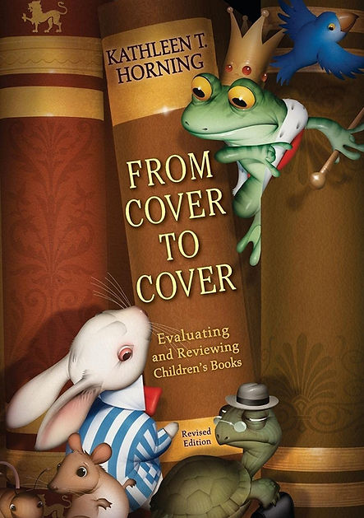 | From Cover to Cover  Evaluating and Reviewing Children's Books  by Kathleen T. Horning  Whether you're a seasoned book reviewer or brand new to writing reviews, this book teaches you how to write professional reviews for children's literature.  Image Source: amazon.com
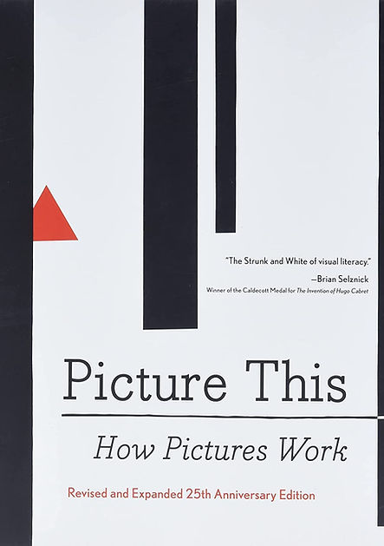 | Picture This: How Pictures Work  by Molly Bang  ​  Picture books are a staple of library collections and storytimes. Have you ever wondered how art works its magic? Molly Bang explores how illustrators use color, shape, size, and more to tell riveting stories through art.  ​  Image Source: amazon.com
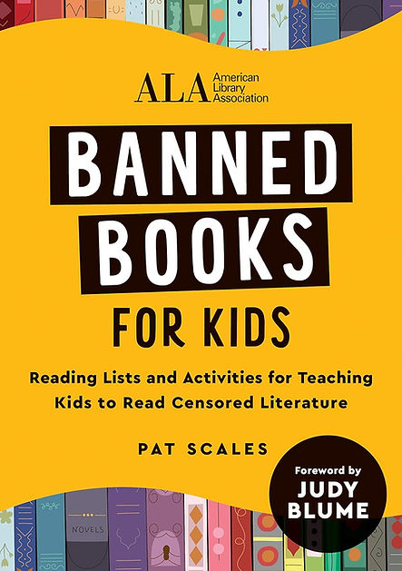 | Banned Books for Kids  Reading Lists and Activities for Teaching Kids to Read Censored Literature  by Pat Scales  As book challenges skyrocket, how can we discuss banned books with kids? This book not only starts that conversation, but also provides activities for reading and discussing banned books.  ​  Image Source: amazon.com
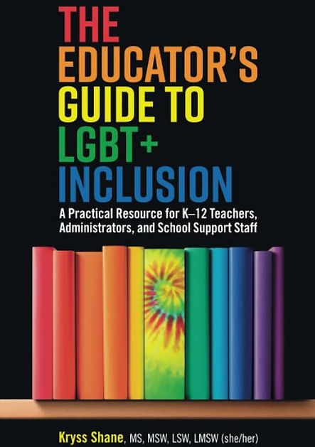 | The Educator's Guide to LGBT+ Inclusion  by Kryss Shane  A must-read for children's librarians, school librarians, and teachers. This guide provides educators a thorough exploration of how schools can best support LGBTQ+ youth, so kids can thrive as learners and schools can thrive as safe spaces.  Image Source: amazon.com
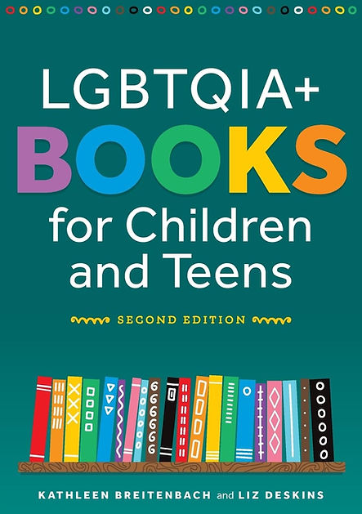 | LGBTQIA+ Books for Children and Teens (Second Edition)  by Kathleen Breitenbach & Liz Deskins  ​  For library professionals developing LGBTQ+ inclusive youth collections, this book is for you! In addition to showcasing LGBTQ+ children's literature, this book discusses the censorship of this literature, demonstrating why to include and how to best include LGBTQ+ literature.  ​  Image Source: amazon.com
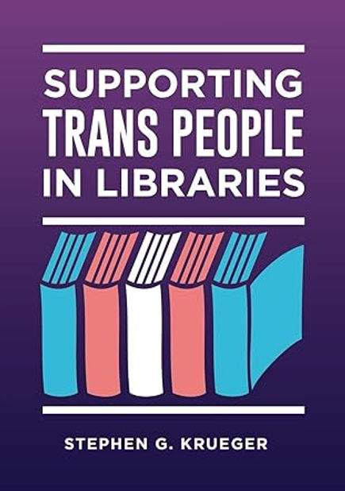 | Supporting Trans People in Libraries  by Stephen G. Krueger  ​  Transgender patrons face unique barriers in libraries. Stephen G. Krueger discusses best practices for meeting the nuanced needs of transgender patrons and transgender staff in library spaces, programs, and services.  ​  Image Source: amazon.com
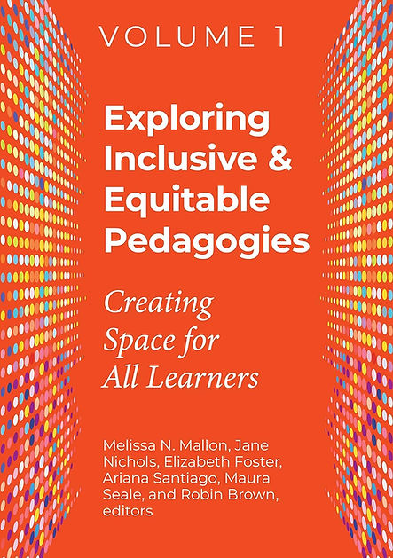 | Exploring Inclusive & Equitable Pedagogies: Creating Space for All Learners (2 Volume Series)  by Melissa N. Mallon, Jane Nichols, Elizabeth Foster, Ariana Santiago, Maura Seale, & Robin Brown (editors)  ​  This two-volume series explores a variety of DEI topics, such as accessibility, cultural competence, and Universal Design for Learning. This series can empower librarians to make their library a truly safe space for all learners.  ​  Image Source: amazon.com
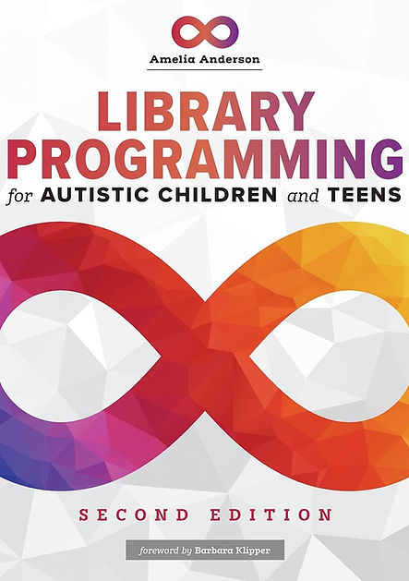 | Library Programming for Autistic Children and Teens (2nd Edition)  by Amelia Anderson  ​  This programming guide provides guidelines and resources for libraries to serve often underserved autistic children and teens. In addition to discussing best practices for programs, such as storytimes and library visits, this guide provides examples of programs offered at libraries. A fantastic resource for welcoming autistic patrons to public and school libraries.  ​  Image Source: amazon.com
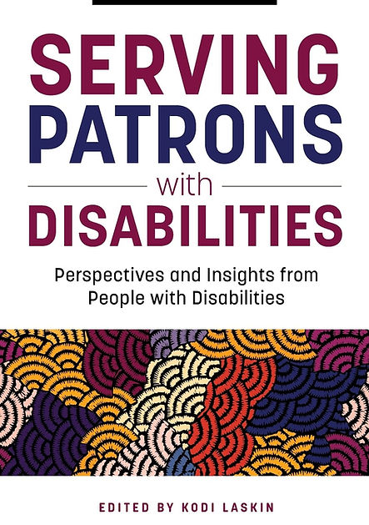 | Serving Patrons with Disabilities  Perspectives and Insights from People with Disabilities  by Kodi Laskin (editor)  ​  This guide explores how libraries can best serve patrons with disabilities, such as vision, hearing, mobility, and learning disabilities. With a topic as expansive as accessibility, this guide presents this topic in a way that empowers libraries to truly make their spaces and programs accessible to all.  ​  Image Source: amazon.com

